Name
Address
Address
Postcode
Date

Dear <Name>

We all want to make sure that our families are taken care of when we’re not around anymore so you may want to think about your options for planning for the future.

With funeral costs having risen significantly over recent years, with the average cost of a UK burial using a funeral director being £4,257 (London approx. £8,000)**, an Over Fifties Life Plan can help provide a valuable cash lump sum for your family. This could cover the cost of a funeral, go towards mortgage repayments, leave a small legacy for your loved ones or even offer a safety net against any outstanding debts.
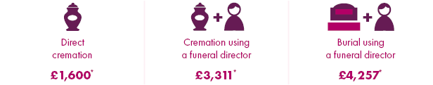**
An Over Fifties Life Plan is guaranteed, meaning you can get cover without answering any medical questions. You can also choose how much to pay on a monthly basis, to make sure it’s affordable. You only need to answer a few simple questions and you can be covered in minutes.

It’s impossible to put a value on life, but taking out an Over Fifties Life Plan can give you and your family peace of mind that when you die your funeral costs are covered and you have helped to provide for your family’s future.

If you would like to discuss the options available to you please call us on <*************>.

Name
Adviser Signature
Contact details
** Source: www.moneyadviceservice.org.uk (October 2017)

